**Assignment 1**

CSC103-Programming Fundamentals



Submitted by:

**Ahmad Bin Mustafa**

**SP23-BCS-011**

**A**

Submitted to:

**Mr. Abdul Karim Shahid**

Submitted on: **March 3, 2023**

**Department of Computer Science**

**COMSATS University Islamabad**

**Lahore Campus**

**Exercise 2**

 Write a program that prints the numbers 1 to 4 on the same line. Write the program using the following methods.

1. Using one printf statement with no conversion specifiers.
2. Using one printf statement with four conversion specifiers. printf("%d%d%d%d",1,2,3,4) //Here %d is the conversion specifier use to print integer values on the screen
3. Using four printf statements

PROGRAM

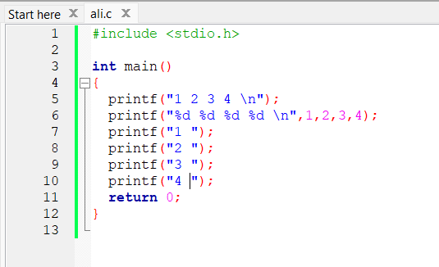

OUTPUT

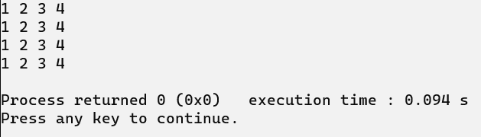

**Exercise 3**

Write a C-Program to perform the simple arithmetic operations (addition, subtraction, multiplication, division, and remainder).

PROGRAM

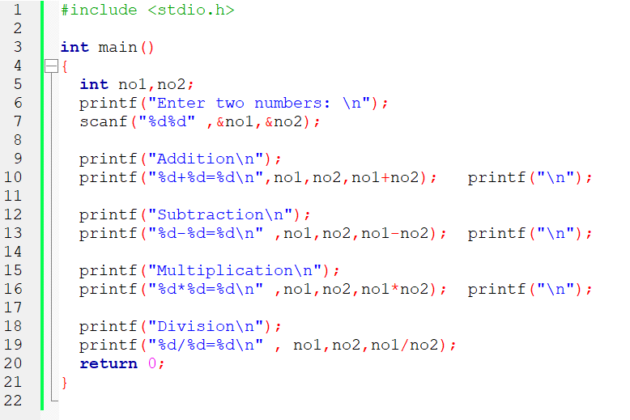

OUTPUT

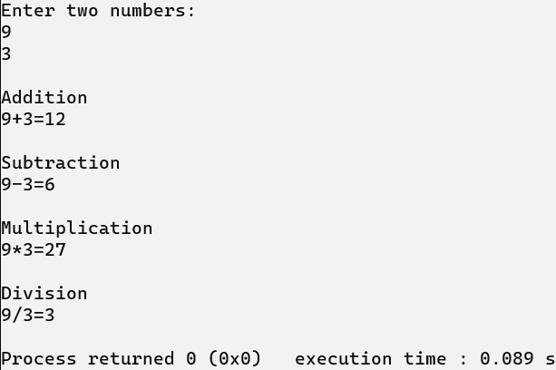

**Exercise 4:**

Write a C-Program to swap two integer numbers without and with using third variable.

PROGRAM

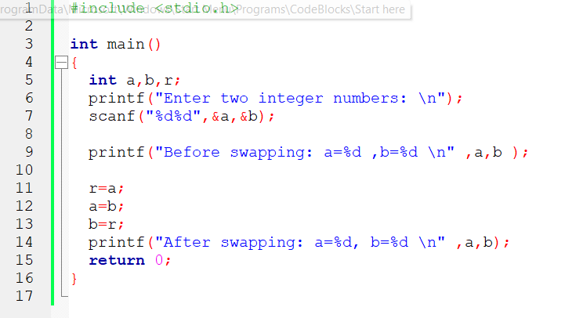

OUTPUT

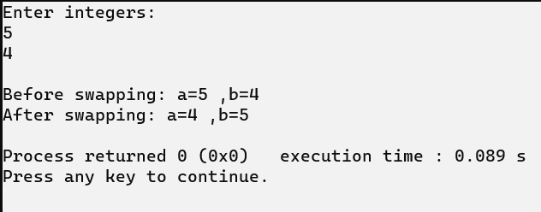

PROGRAM

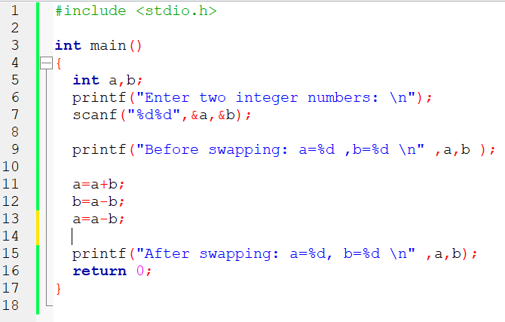

OUTRPUT

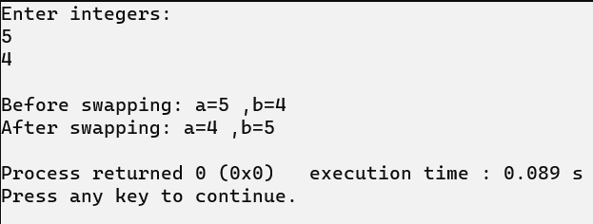

**Exercise 5:**

Write a C-Program to calculate area and Perimeter of the triangle.

[Area of triangle= ½ x base x vertical height]

[Perimeter of triangle =  a + b + c]

PROGRAM

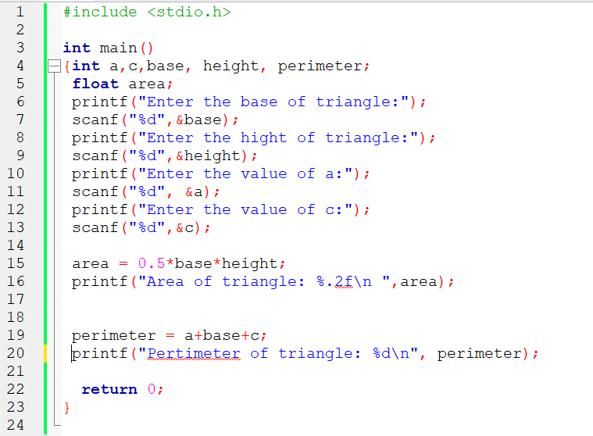

OUTPUT

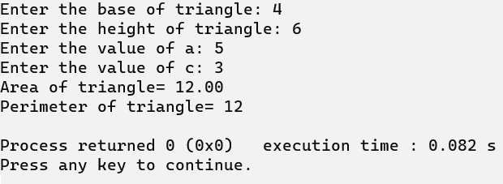

Declare variable base, vh and total_area

Calculate area of triangle total_area = 0.5 * base * vh

Print total_area of triangle triangle

Exersice 1 Print the given shapes.

